**Figure 1. Illustration of KKT condition using a toy example.** The exemplary concave function $Q\left(h^{2}\right)$ was created to enable determination of the optimal value that maximizes $Q\left(h^{2}\right)$ within the parameter space. The parameter $h^{2}$ can be between zero and one, and the parameter space for this value is grayed out. (A) If the value that maximizes $Q\left(h^{2}\right)$ is negative, the tangent slopes at both zero and one will be negative. A tangent slope that is negative at one violates the KKT conditions, however, a negative tangent slop at zero satisfies the KKT conditions, so the maximizer within the parameter space is zero. (B) When the value which maximizes $Q\left(h^{2}\right)$ is greater than 1, the optimal value is one since positive tangent slope at one meets the KKT conditions. (C) When the maximizer is located in the parameter space, tangent slopes at both boundaries of the parameter space do not satisfy the KKT conditions. Therefore, restrictions do not affect the result of optimization.

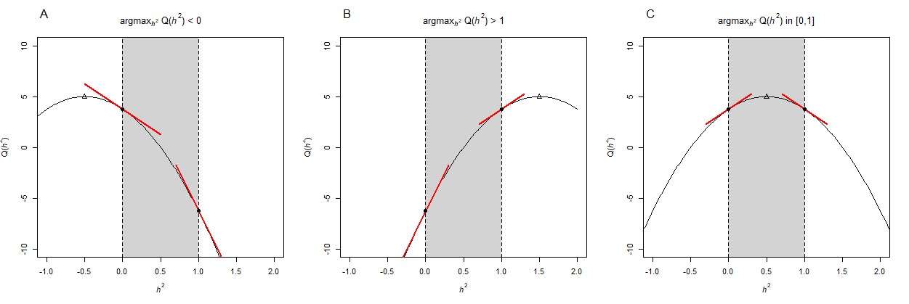

**Figure 2. Boxplots for $\hat{h^{2}}$ for randomly selected families (scenario 1).** True heritability was 0.05 (top), 0.2 (middle), and 0.4 (bottom) and was indicated as a gray dashed line.

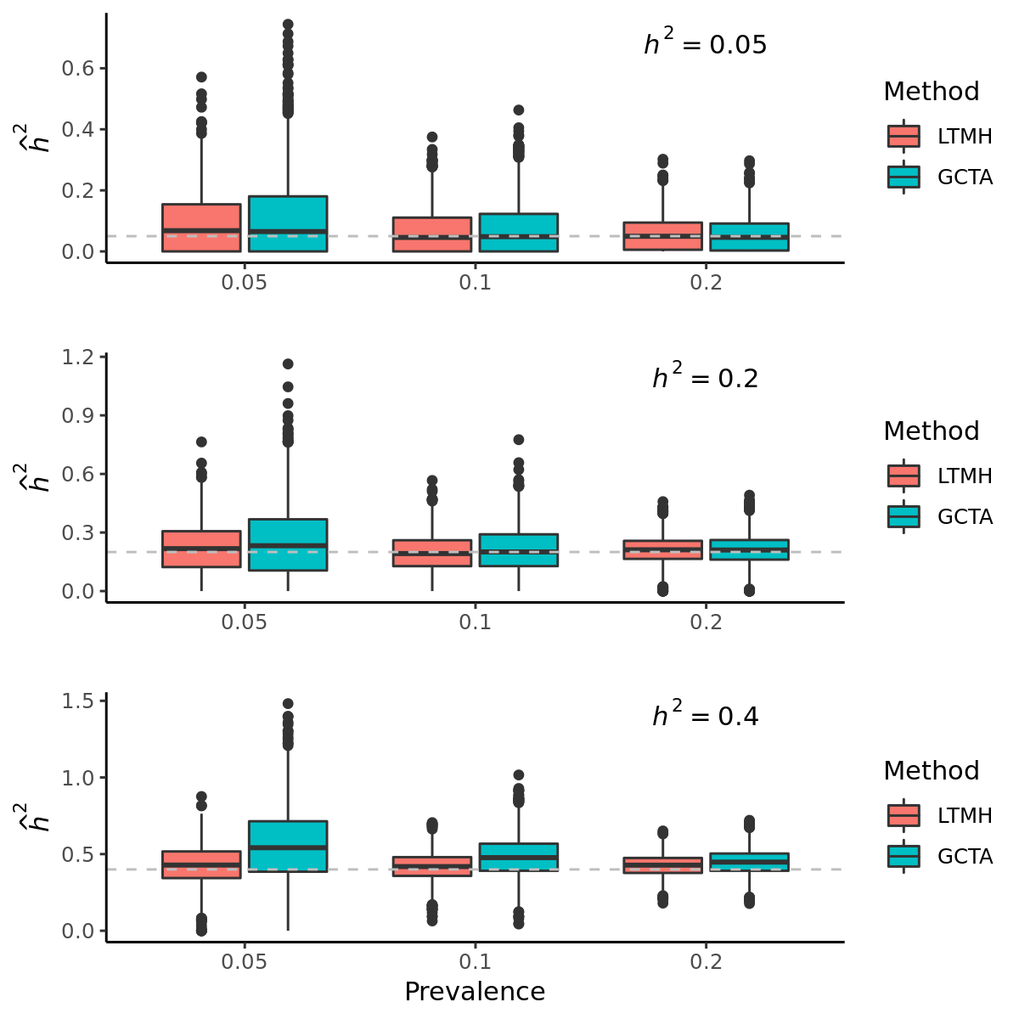

**Figure 3. Estimation of risks for T2D according to age.** For a certain individual, we assume that he/she has two parents and one younger sibling, and the risk of T2D development was calculated as a function of his/her age and the number of affected family members. The X-axis indicates age of individual, and the age of his/her father and mother were assumed to be 29 years old. The younger sibling was assumed to be 3 years younger than the participant. $h^{2}$ and the coefficient of unstandardized age were set to be 0.2944 and 0.051, respectively. (A) Probability of the participant being affected according to the number of affected family members, and (B) relative risks of being affected according to the number of affected family members.

